Hoot Owl Days
Food Vendor
Sat., Aug. 28, 2021
Fun in the Park!
10:00am – 5:00pm
Hubbard Hoot Owl Days
Heffernan Park
Hubbard, NE

Contact person Donella 712-223-2913 or kassybaby123@yahoo.com

Name______________________________________________________________

Address____________________________________________________________

Phone #____________________________________________________________

Email______________________________________________________________

Product Description__________________________________________________

All spots outside – Bring your own trailer, table, tent, chair, etc.
Sat. Aug 28, 2021 10:00am – 5:00pm

Send form and $50 by Aug. 1, 2021 ($60 after Aug. 1) to:
Hubbard Betterment
PO Box 160
Hubbard, NE 68741
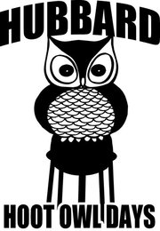
Fun in the Park!

Come to Hubbard – We’ll have a “HOOT”!

