Hoot Owl Days
Non-Food Vendor
Sat., Aug. 28, 2021

10:00am – 5:00pm

Hubbard Hoot Owl Days
Heffernan Park
Hubbard, NE

Contact person – Donella at 712-223-2913

Name______________________________________________________________

Address____________________________________________________________

Phone #____________________________________________________________

Email______________________________________________________________

Product Description__________________________________________________

All spots outside – Bring your own trailer, table, tent, chair, etc.
Sat. Aug 28, 2019 10:00am – 5:00pm

Send form and $5 by Aug. 1, 2021 to:
Hubbard Betterment
PO Box 160
Hubbard, NE 68741
NEW! Lower price
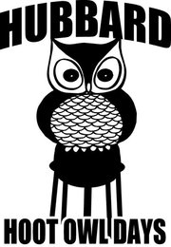
Fun in the Park!

Come to Hubbard – We’ll have a “HOOT”!

